

Intrusion Analysis and Response
Assessment 1: Network Intrusion Analysis
Module Coordinator: Zachary Richards

Date of submission: 29/03/2024
Number of words: 3067

Abstract:
A general examination of malware behaviour via FlareVM and REMnux in a virtualized setting is the subject of this study. The process commences with tweaking Windows Defender, Firewalls, and Updates through the registry to enable us to install FlareVM. After this stage is over, FlareVM is installed via Windows PowerShell and then failed installations are identified and installed using Chocolatey. To do dynamic analysis of SampleMal, INetSim on REMnux will be used to impersonate DNS, FTP and HTTP services that mimic a Command and Control (C2) server. It also provides an analysis which includes static and dynamic analysis techniques such as PEStudio, Cutter, OllyDbg among others that expose its ability to manipulate files within itself or outside itself as well as network communication with other computers in its neighbourhood or those linked directly or remotely to it through internet among others like system interactions. Malware capabilities identified in the research include file manipulation, process creation and network communication; they also involve encryption methods or obfuscation techniques.
Contents
Abstract: 2
Introduction: 2
Setting the virtual environment for reverse engineering and Malware Analysis: 2
Fingerprinting SampleMal binary executable file: 7
General Purpose of the File: 10
Static Analysis: 10
Dynamic Analysis: 14
Structure of the main function: 23
Advice for preventing and minimizing attacks: 29
Conclusion: 29

Introduction:
The practice of malware analysis is an important facet of cybersecurity that results in the identification of malicious activities and the creation of countermeasures. The current research dwells in the examination of a malware sample, SampleMal using FlareVM, and REMnux done in a virtualized environment. To enable FlareVM installation which is a malware reverse-engineering virtual machine, initial steps involved disabling Windows Defender, Firewalls, and Updates. As for what happens next, after installation I proceed to analyse the behaviour of this malware by studying network communication, file manipulation and system interactions employing static as well as dynamic analysis methods.

Setting up the virtual environment for reverse engineering and Malware Analysis:
Turning off Windows Defender, Windows Firewalls and Windows Updates in regedit to install FlareVM. (Collins, 2023)
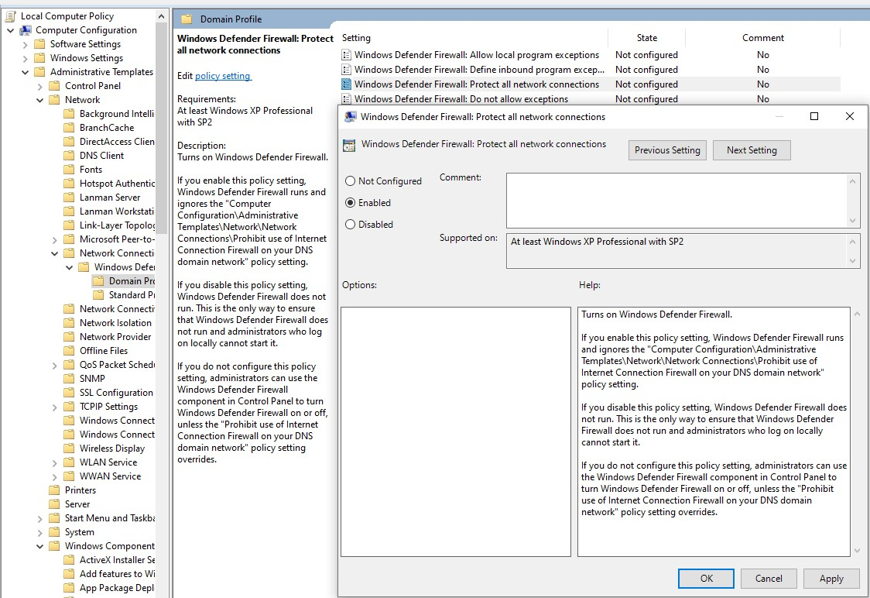
Then I started the installation through Admin Windows Powershell.
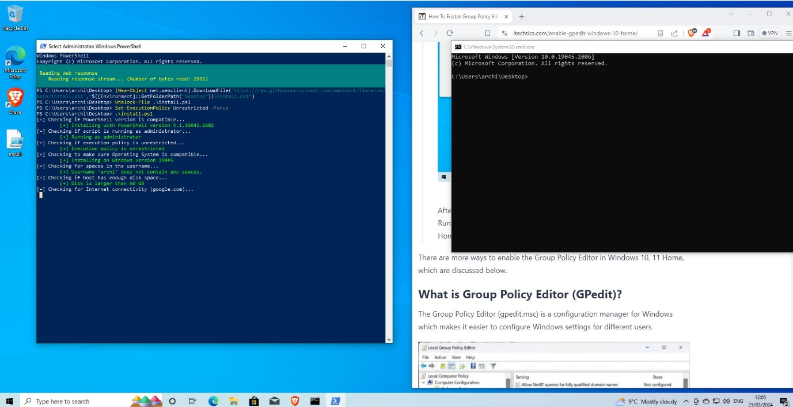
FlareVM and programs installing.
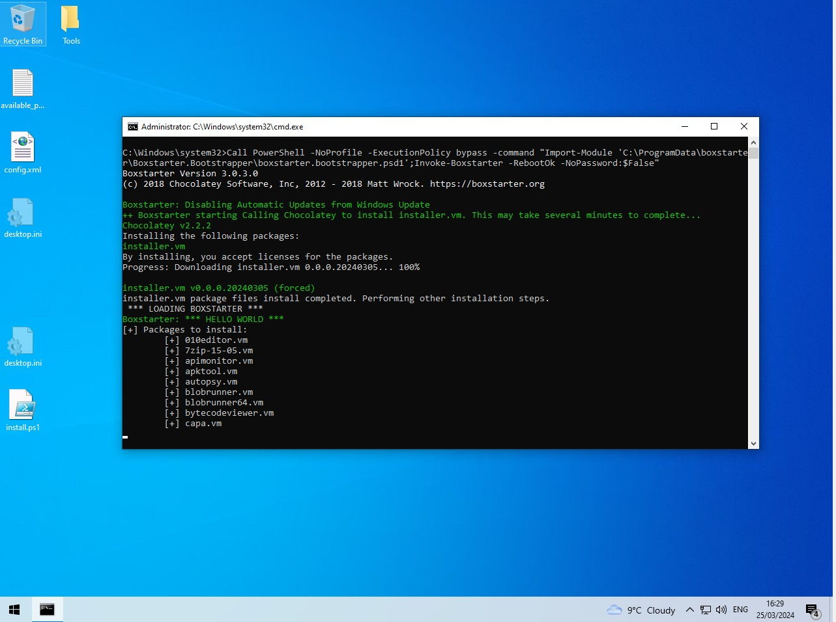
FlareVM loaded however had some failed installations I had to manually install.
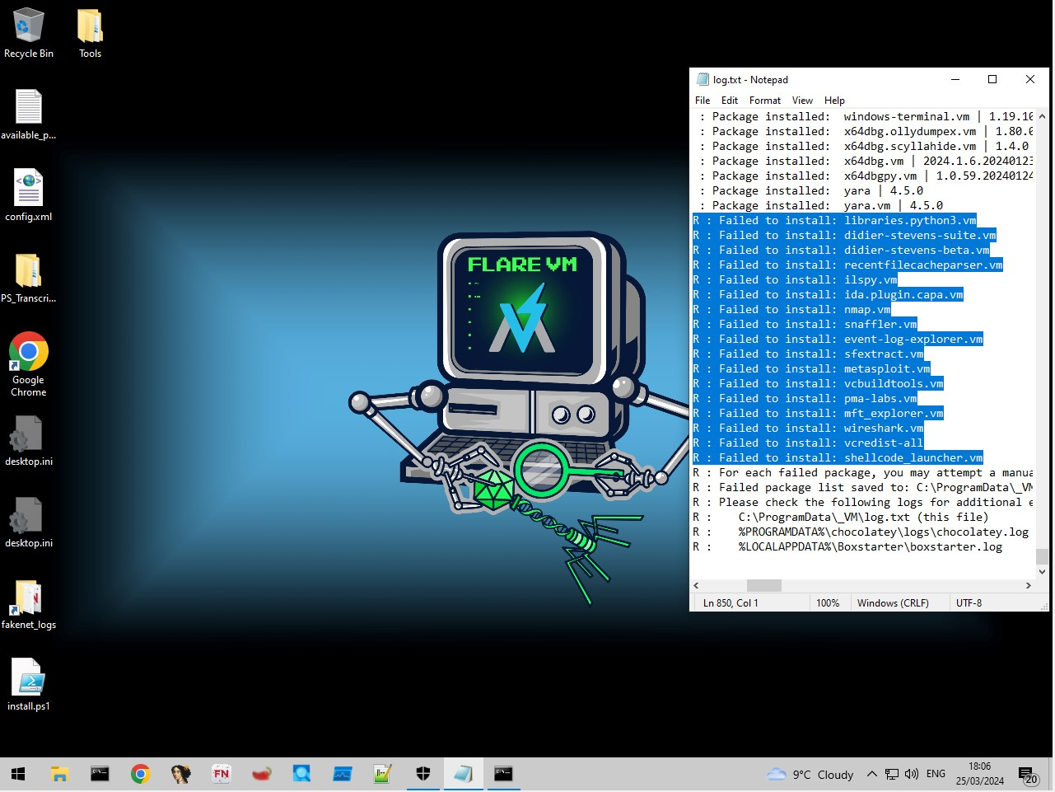
Installed failed installations using choco install (package) –ignore-checksums
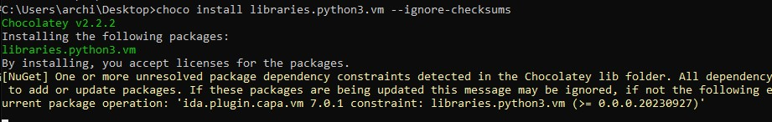
Now I have done the static analysis of the malware, I need to do the dynamic analysis and I need to set up another Virtual Machine called remnux so I can impersonate the DNS, FTP & HTTP service using the inetsim function in remnux, this will act as a C2 server (command-and-control). (feroot, 2023) I need to connect both VMs in virtual box and set them to a Host-Only Adapter so they can ping each other. The Image below shows that both of the VMs are on the same network adapters with the IPs of 10.0.0.2-10.0.0.254. (Collins, 2023a)
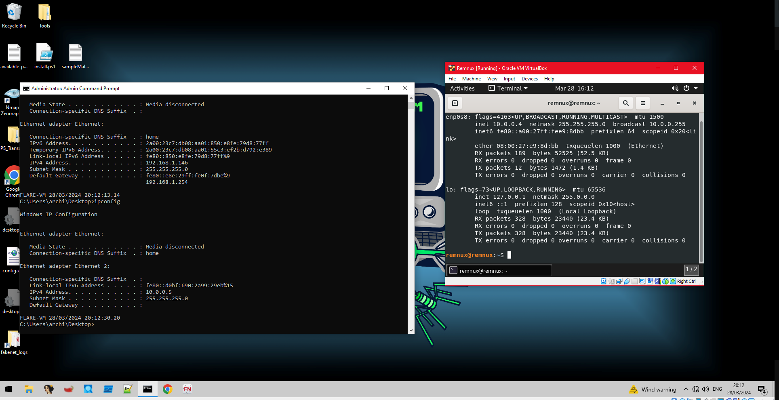
This screenshot shows successful ping requests to each VM.
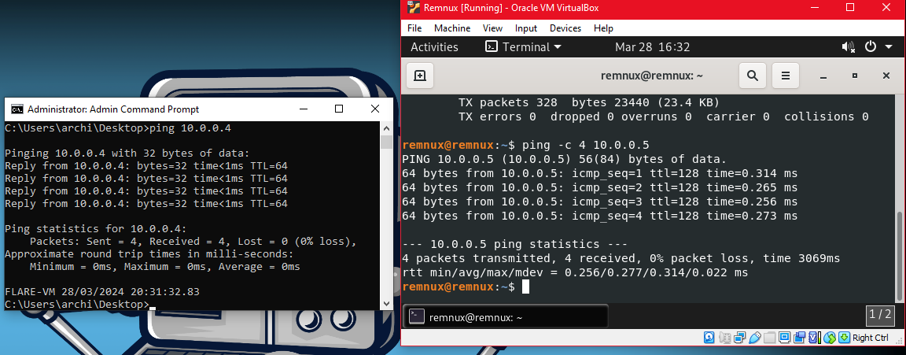
The screenshot below shows INetSim server working from hosted from Remnux linux and procmon in the background for when I open the SampleMal executable.
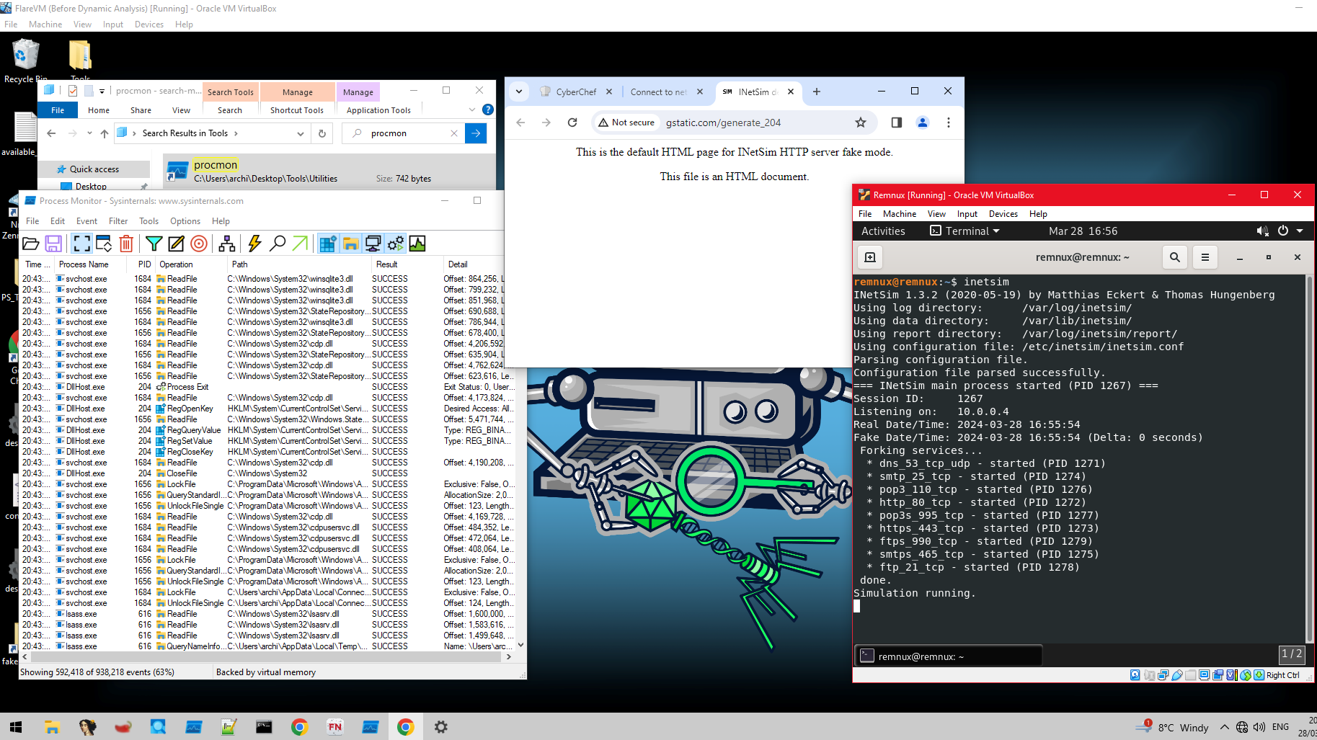

Fingerprinting SampleMal binary executable file:
VirusTotal scan of SampleMal executable on the detection page:
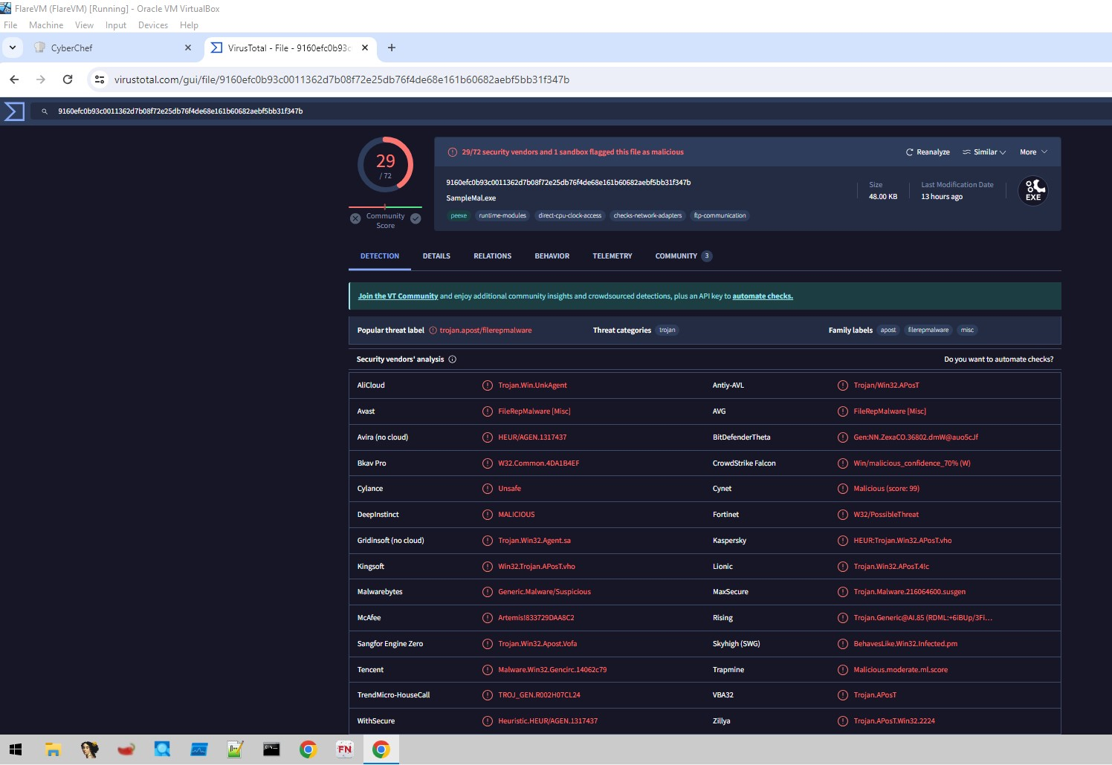
VirusTotal details page containing hashcodes and metadata:
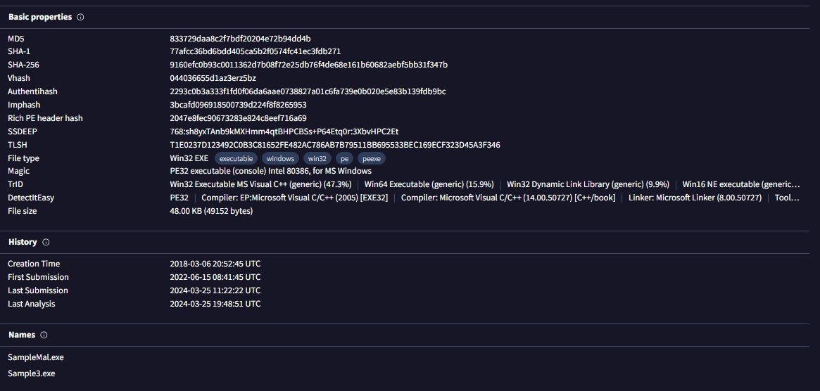
VirusTotal details page containing portable executable info and imports:
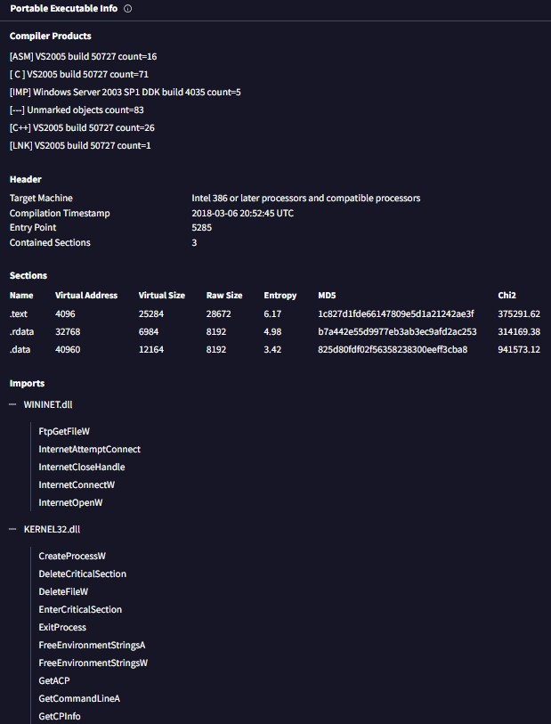
Now inspecting the SampleMal executable using PEStudio:
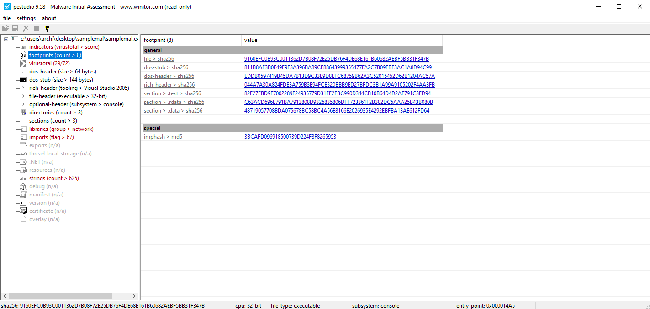
Hashs:
General | Hash
file > sha256, | 9160EFC0B93C0011362D7B08F72E25DB76F4DE68E161B60682AEBF5BB31F347B
dos-stub > sha256, | 811B8AE3B0F49E9E3A396BA89CF88643999355477FA2C7B09EBE3AC1A8D94C99
dos-header > sha256, | EDDB0597419B45DA7B13D9C33E9D8EFC68759B62A3C52015452D62B1204AC57A
rich-header > sha256, | 044A7A30A824FDE3A759B3E94FCE320BBB9ED27BFDC3B1A99A9105202F4AA3FB
section > .text > sha256, | 82F27EBD9E7002289F24935779D31EE2EBC990D344CB10B64D4D2AF791C3ED94
section > .rdata > sha256, | C63ACD696E791BA7913808D9326835806DFF723361F2B382DC5AAA25B43B080B
section > .data > sha256, | 48719057708BDA075678BC58BC4A56E8166E2026935E4292EBFBA13AE612FD64
imphash > md5, | 3BCAFD096918500739D224F8F8265953
Properties of SampleMal artifact using pestudio:
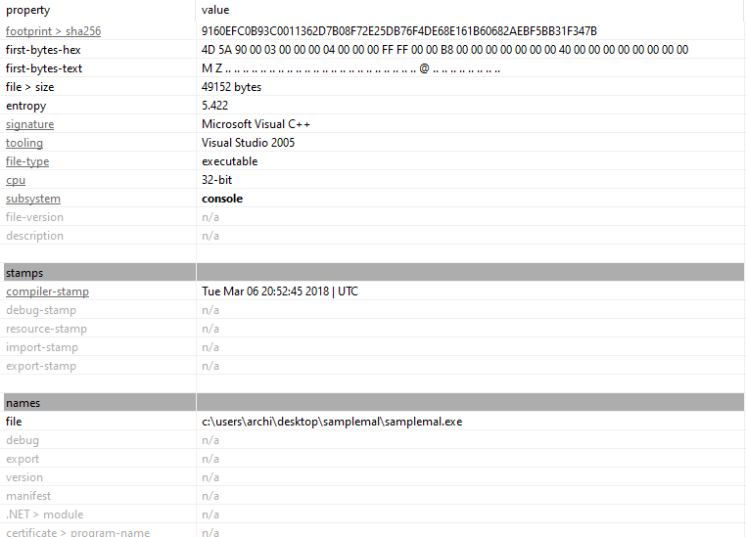

General Purpose of the File:

Static Analysis:
Malware's initial assessment shows that there are three sections to this executable. Section 0 has a execute characteristic and section 2 has a write characteristic.
The property rows of raw-size and virtual-size denote how big the SampleMal value is and shows if the SampleMal is compressed or packed, if the two values are similar then it is likely there is no compression or packing done, which the malware authors do to make sure they can mitigate analysts understanding the functionality of the malicious executable. If the virtual size is much bigger than the raw size then it would suggest that the file is packed. The raw size contains the core functionality of the program, and the virtual size would be packing the malicious code to obfuscate the functionality of the malware. In this example, only section 2 could be considered packed. (Collins, 2023a)

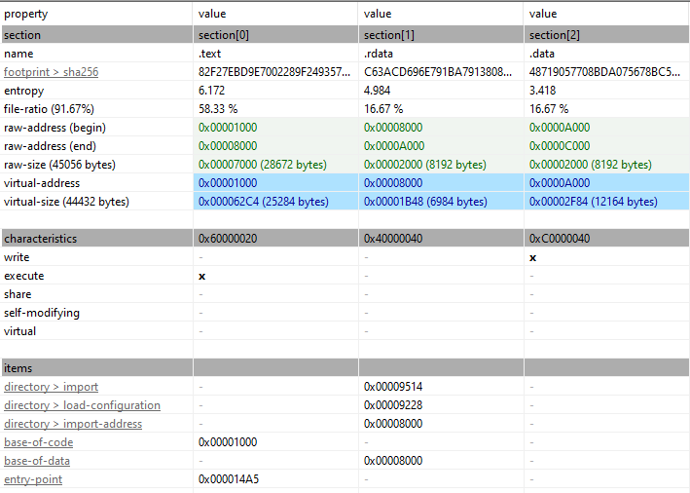
In the libraries section of PEStudio when viewing the SampleMal it shows a flag for Winninet.dll and shows kernal32.
WININET is a file that can get infected or used to attach other malicious files to it, such as Alemod Trojan virus. (mdlee, 2005) This DLL file may contain malicious links or instructions that call 5 imports of internet extensions for the win32 library which could be a reason to why PEStudio has flagged it as potentially malicious.
Kernal32 is an essential component that manages system resources, such as memory, processes, and input/output operations. (Pilici, 2023) Some viruses will replicate under the win32 systems and infect the KERNAL32.dll file. One such virus is called Kriz: “Kriz is a memory resident polymorphic virus. It replicates under Win32 systems and infects PE EXE files (portable executables) with EXE and SCR extensions. It also infects KERNEL32.DLL - Windows core library that allows the virus to always stay resident in memory.” (F-Secure, 2024) DLL files are short for Dynamic Link Library and function as a file that has instructions the other programs call upon to do certain things.

The flags which flag if it is potential malware on the imports give the below artifact some clue as to what the executable could do:
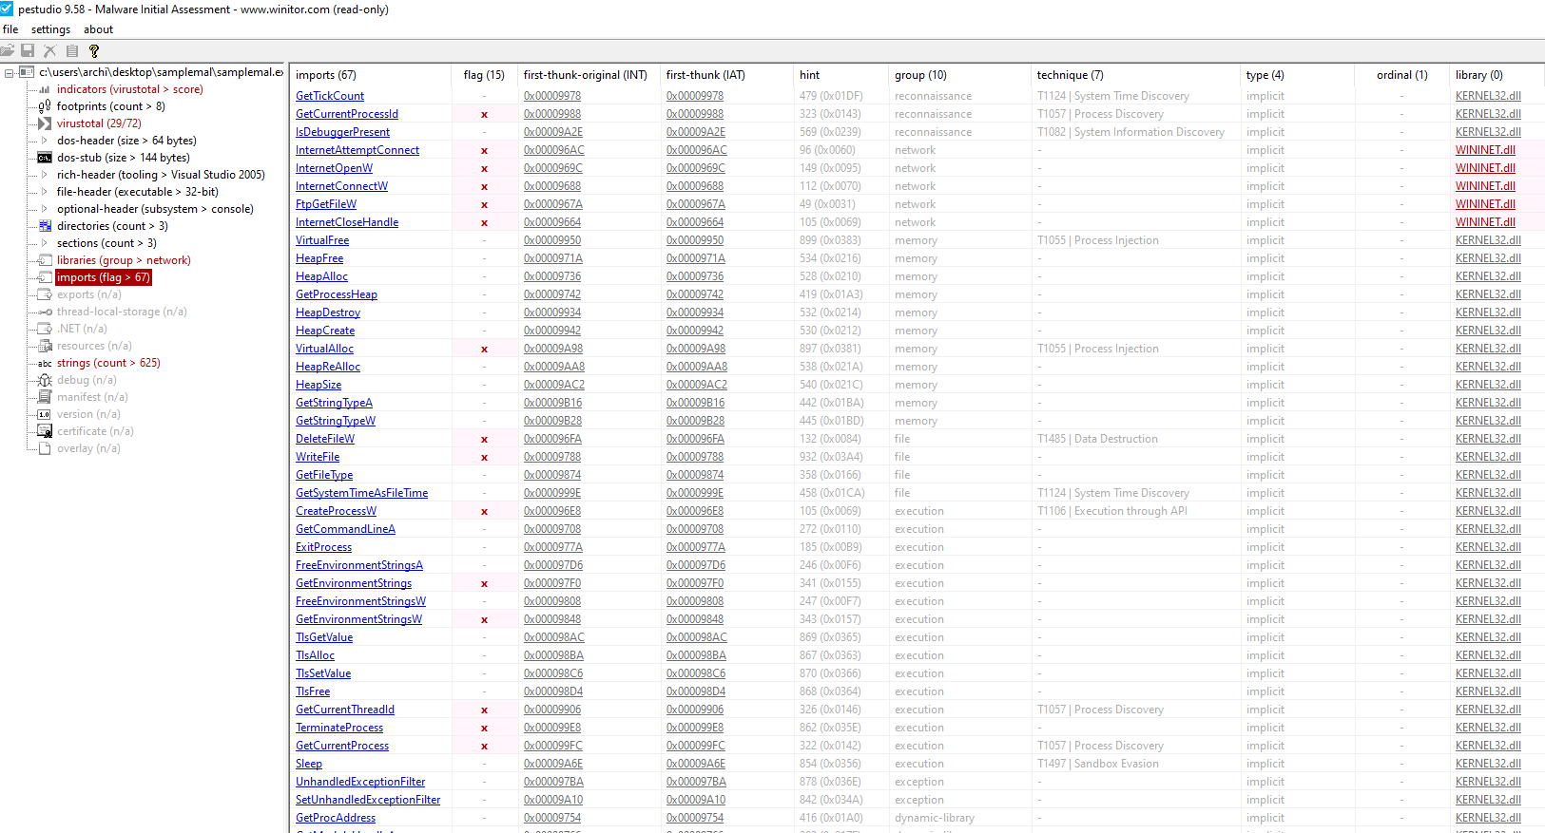
There are a total of 15 flags for import and a total of 15 flags from import and 2 extra ones in the group of desktops.
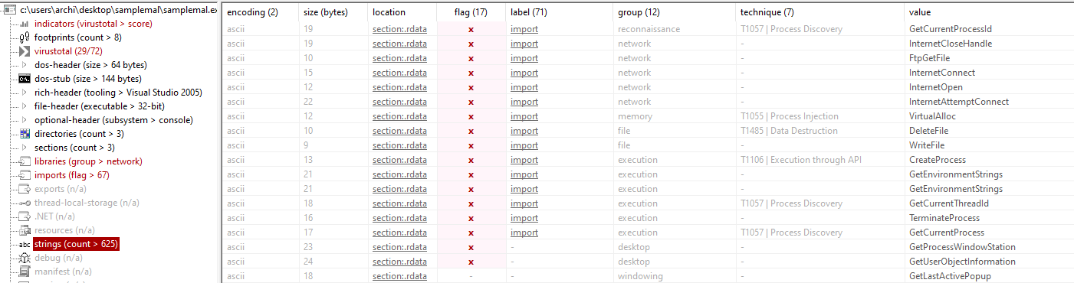
PEStudio on the strings tab helps organise the data and give it labels for the encoding, size, location, flags which show if a , label/tab, group, technique and value, this is very useful because it lays out the data so you can formulate an understanding of what the executable does and what could be an indicator of compromise (IOC): “is an object or activity that, observed on a network or on a device, indicates a high probability of unauthorized access to the system”. (Kaspersky, 2024)
The value tab shows the potentially malicious values that have functionality such as WriteFile, DeleteFile, TerminateProcess, InternetAttemptConnect, and FtpGetFile that all could access and may have the ability to write files, delete files, terminate processes etc, and could all be malicious. (Collins, 2023a)
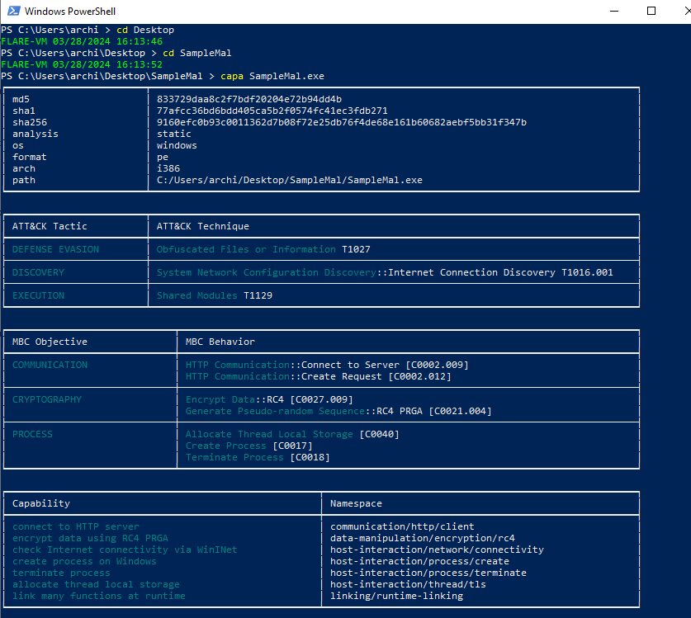
Using capa on the SampleMal.exe we can see that in the ATT&CK box which is the MITRE ATT&CK framework that the Malware uses 3 attack tactics of Defence Evasion, Discovery, and Execution. These categories are useful in understanding the malwares goals. The attack technique gives us more information of what the categories are actually trying to do, for instance in Defence evasion obfuscated file or information (T1027), is trying to make sure that file is unclear or unintelligible. (Mitre, 2024), Then there is System Network Configuration Discovery (T1016) which means malware writers are looking for details about the network configuration and settings, like IP addresses, MAC addresses or configured interfaces and static or dynamic routes. (Mitre, 2024b) Lastly for the MITRE framework techniques are Shared modules (T1129) which means by utilizing shared components malicious actors can deliver payloads. These executable files, known as “shared modules”, are integrated into processes to provide individuals, with the ability to use existing code, such as tailored functions or techniques, for interacting with operating system API functions. (MITRE, 2024)
The MBC objective and behaviour section breaks down what the malware is capable of and its specific behaviours, in this case it has HTTP Communication requests for “create request” and “connect to server”, Cryptography showing an encrypt data “RC4” (also known as Rivest Cipher 4) and generate pseudo-random Sequence “RC4 PRGA”. RC4 is a form of stream cipher that encrypts messages one byte at a time. (okta, 2023) Then there is process objective; this shows process management behaviour of the malware the “Allocate thread local storage”, “Create process”, and “Terminate process”.
Finally, the capabilities sections list the main structure of the malware, such abilities like communicating with HTTP server, encrypting data with RC4, testing internet connection, creating, and terminating processes, and allocating thread local storage. Such capabilities are found in the malware’s code as per using the capa function from FlareVM. (Mandiant, 2020)
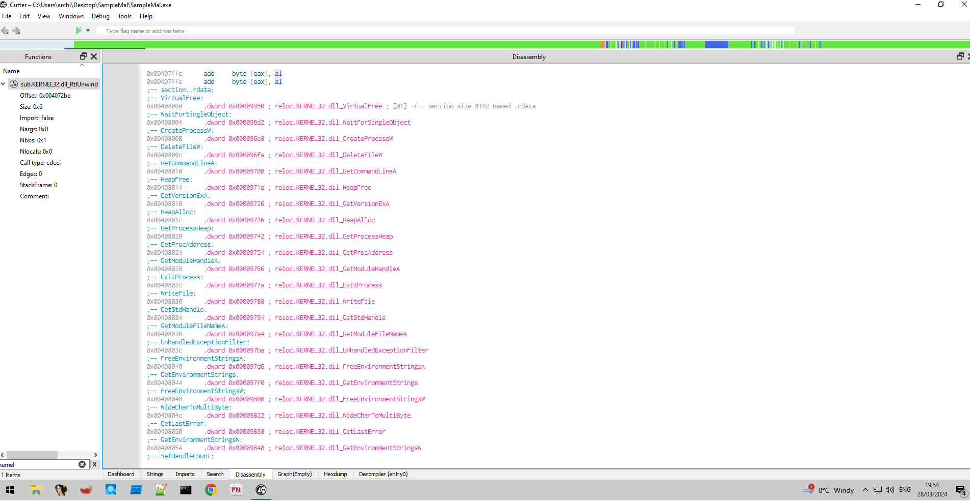
Using cutter, I searched for the kernal32 file and searched for functions that may write something to the kernal32 of windows and I found ExitProcess, WriteFile and GetHandle functions being called in assembly and it shows that there are malware function s to write something to a system32 file.

Dynamic Analysis:
When running the malware on the FlareVM I am running an application called procmon to see what happens to the operating system the executable is ran. This is the very start of what happens when running the SampleMal.exe file:
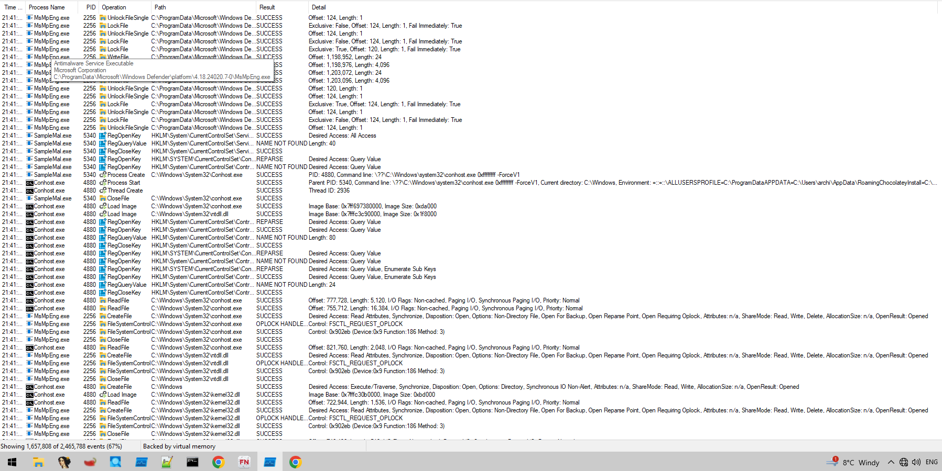
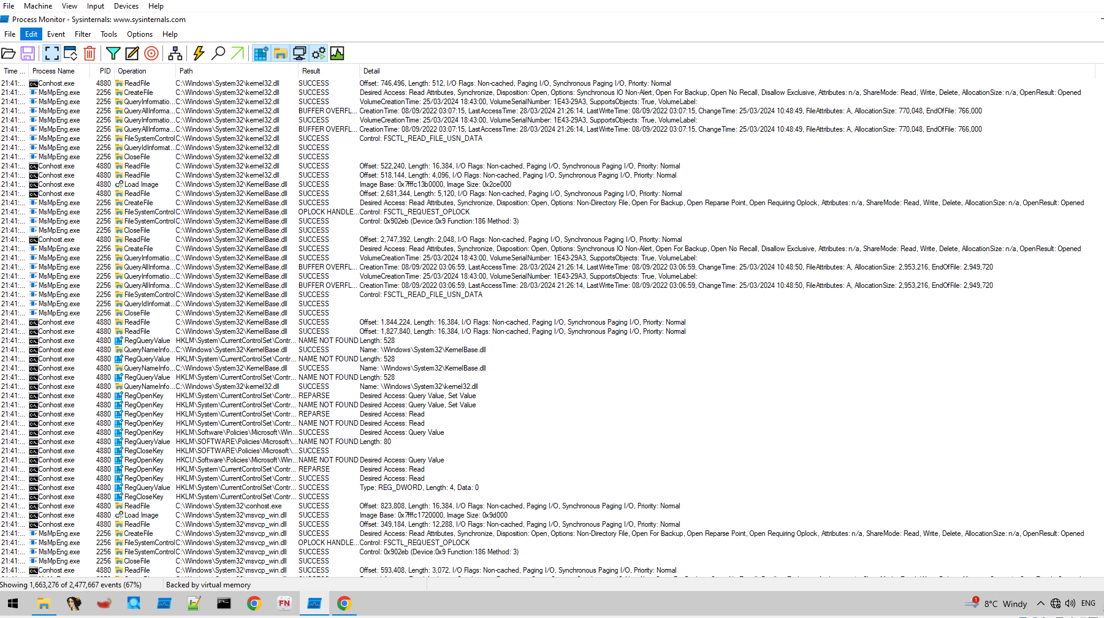
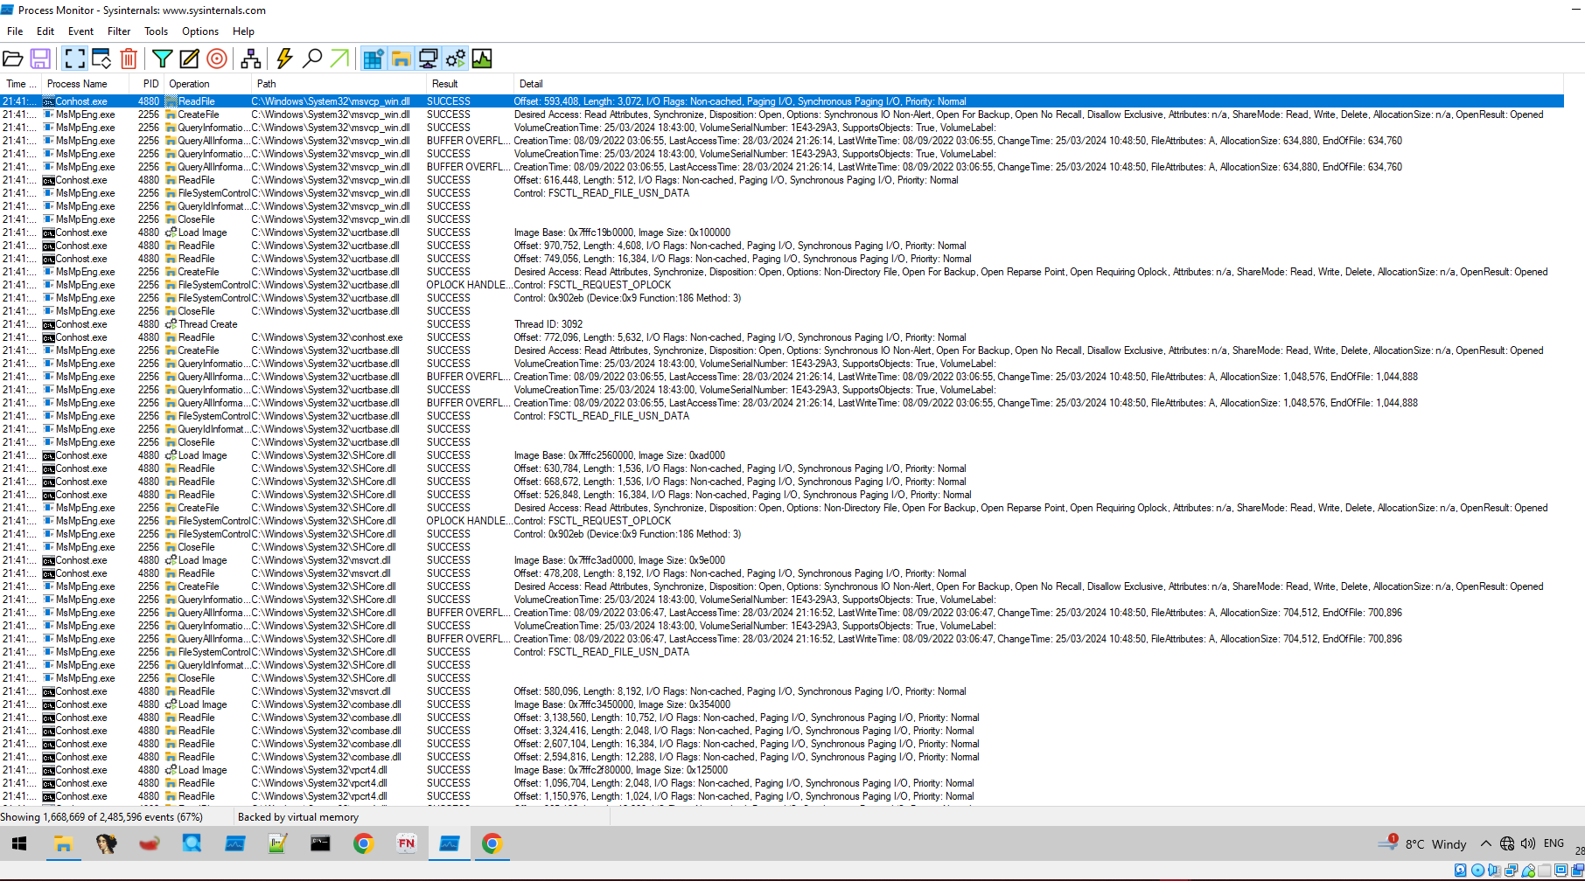

This image shows the console being opened and trying to read a file and load images as well as change windows registry keys and values.
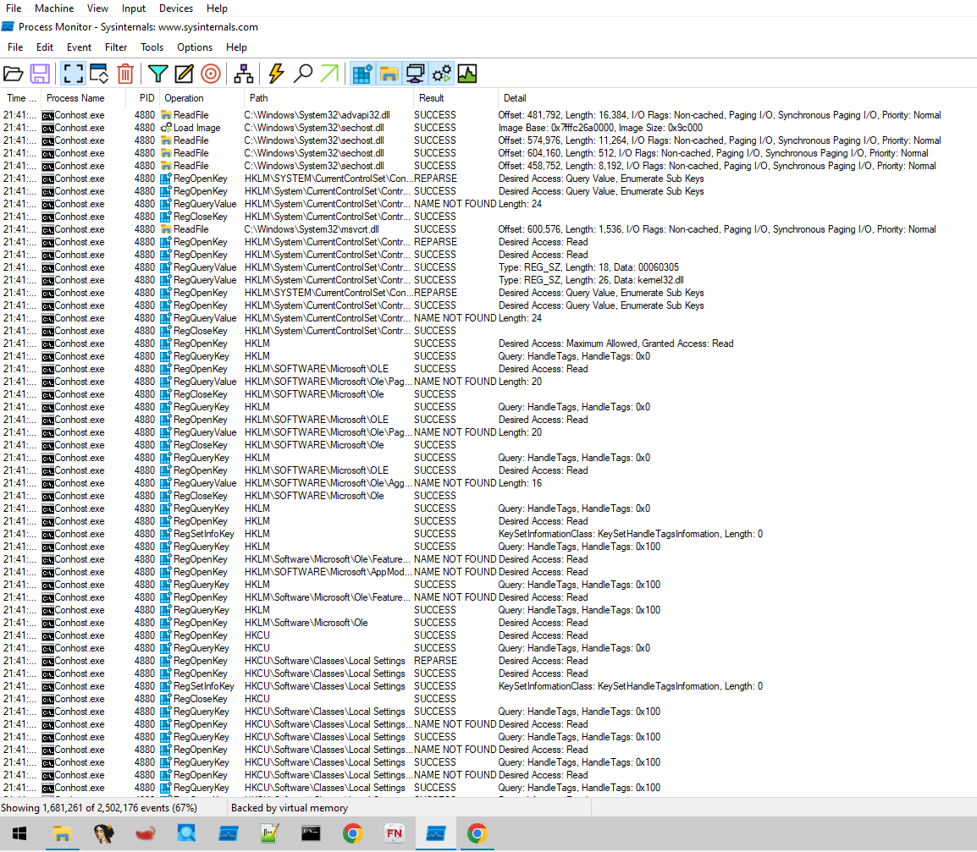
In this screen shot I have selected to only show network activity to filter out and get a better understanding of how the malware effects any victims networks.
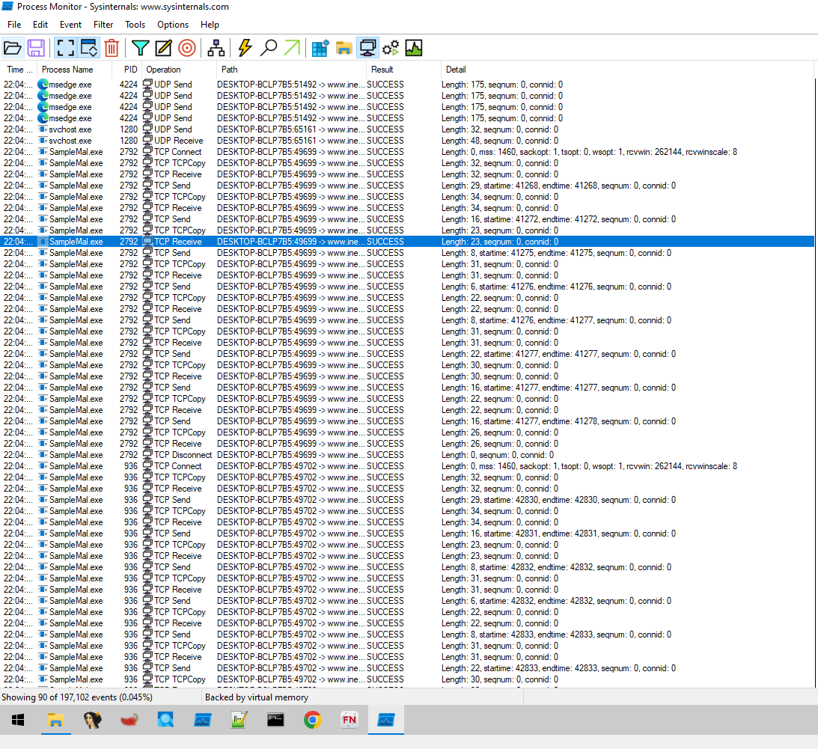
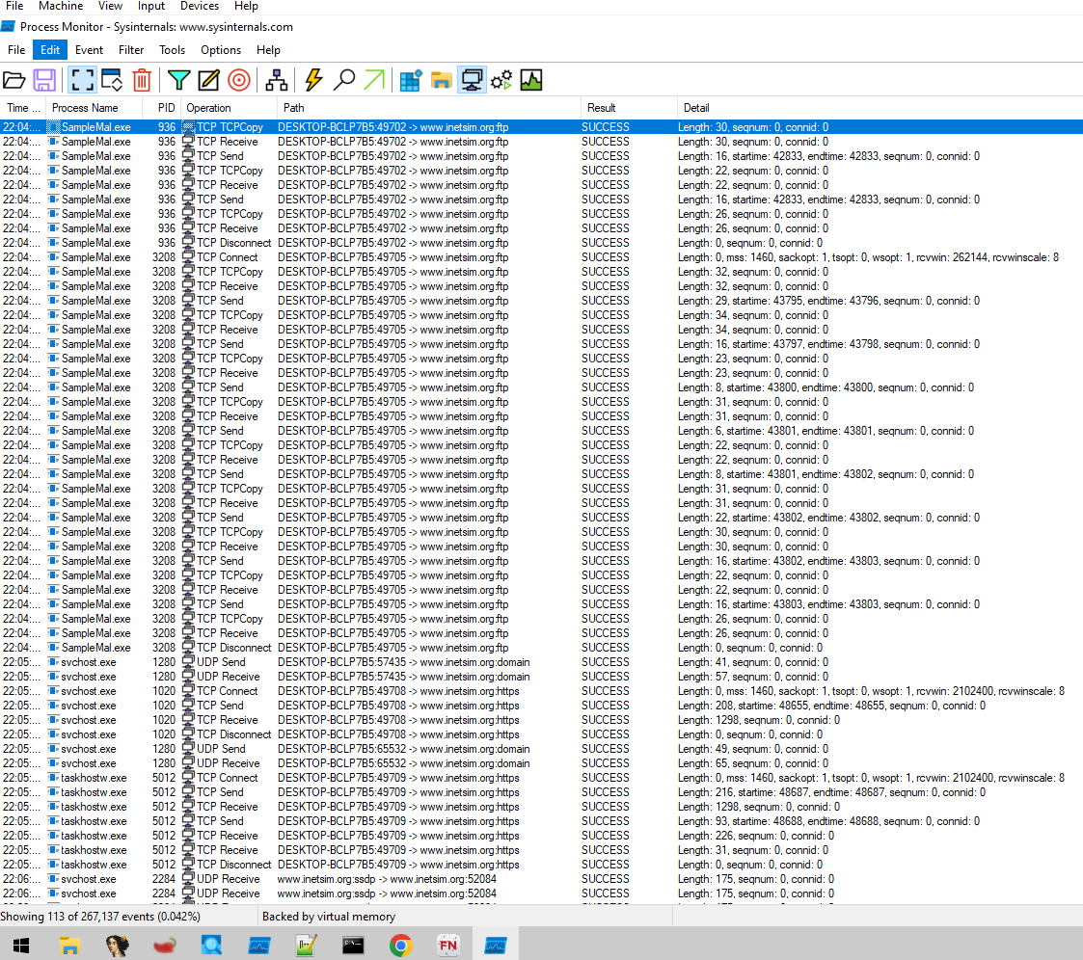
This shows that the malware makes TCP operation requests and asks to TCPCopy, Receive, and Send. Which all go from the virtual machine to the linux inetsim page.

Then this screenshot is with the show process and thread activity filter selected after the malware is ran, this shows the malware loading multiple system32 images and creating many threads.

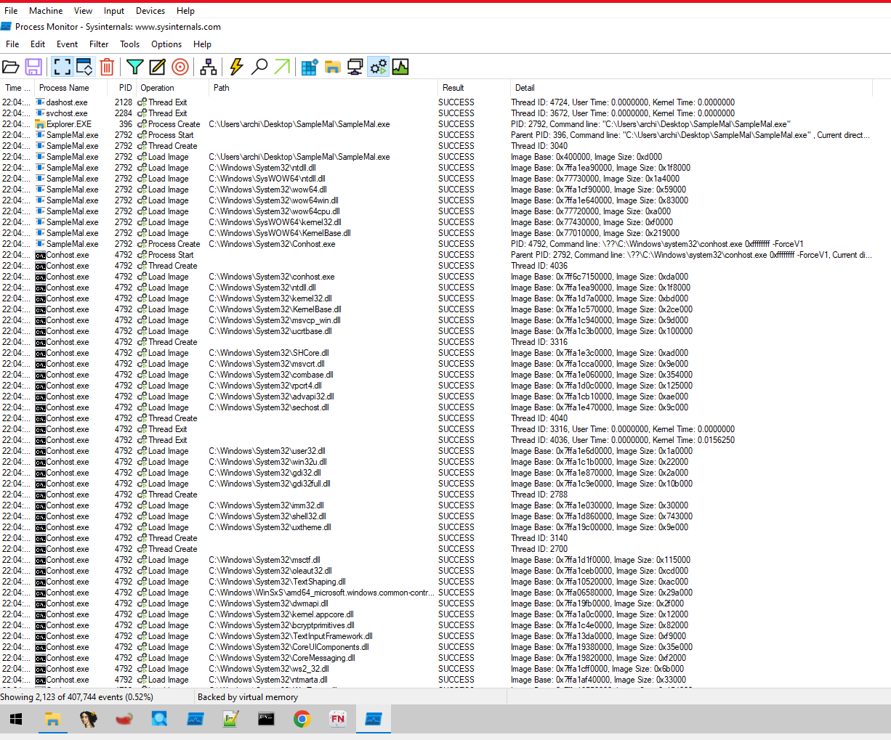
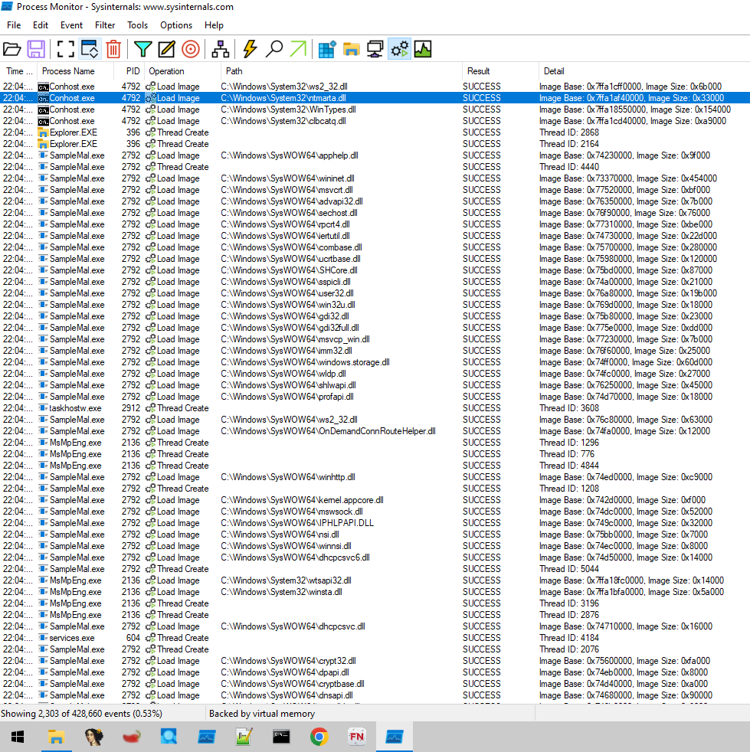
This image shows the SampleMalware now loading images and creating threads successfully in the SysWOW64 directory and loading DLL files.

This screenshot shows the SampleMal file to use Thread Exit operations and other processes which most of them seem to be related to the malware, such as Conhost.exe, DllHost.exe, NisSrv.exe as it is directly below or in-between SampleMal.exe and Conhost.exe operations.
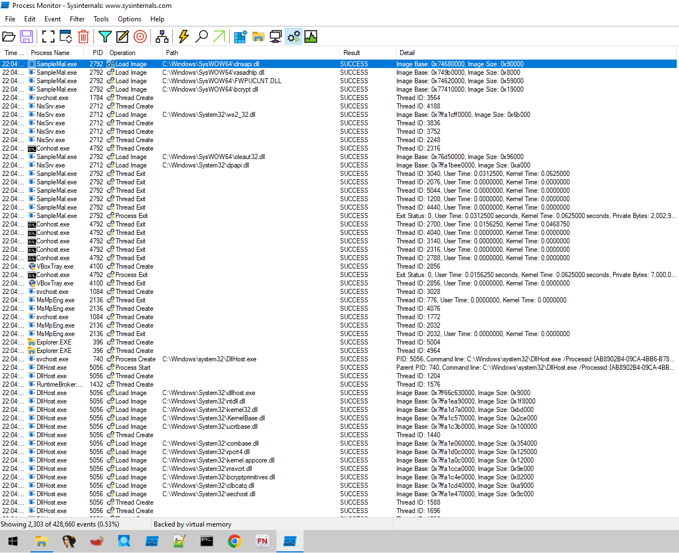
In the screenshot below it shows the Process Profiling Events and Thread activity, After the thread activity of SampleMal and Conhost.exe, the process profiling shows the Wininit.exe and winlogon.exe files to run and be executed successfully.
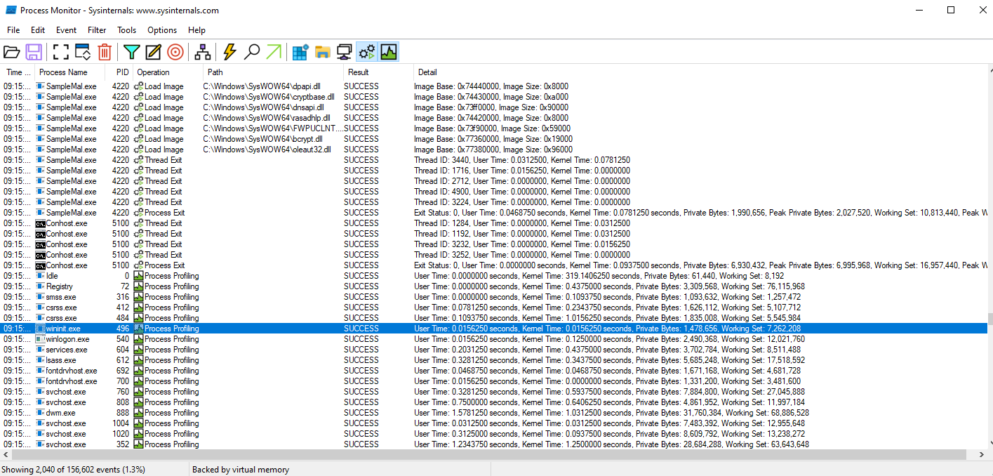
In this screenshot it shows the File system Activity and the SampleMal.exe is doing these operations in SysWOW64 directory; ReadFile, CreateFile, QueryBasicInformationFile, CreateFileMapping, CloseFile, QuerySecurityFile, and QueryNameInformationFile. The utilization of CreateFileMapping implies that it could be trying to map files into memory, for retrieval or to conceal its actions. The sequence of these tasks might signal behaviours, such, as data theft, injecting code or generating malicious software payloads.
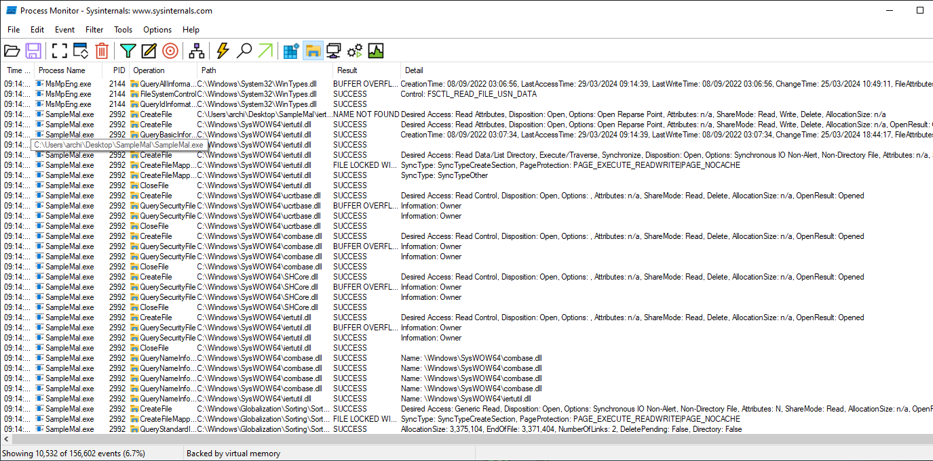
In this screenshot below I have selected only the show registry activity to see what regedit operations and paths the SampleMal.exe process does, in this case it uses the operations of RegOpenKey, RegQueryValue, RegCloseKey and RegSetInfoKey. All of these operations are done in the HKLM folder in specific directories such as HKLM\System\CurrentControlSet\Control\Session Manager, this is where the operation RegSetInfoKey is used.
The HKLM\System\CurrentControlSet\Control\Session Manager pathway stands out, since it plays a role in overseeing functions of the Windows operating system, such, as managing sessions configuring boot options and organizing the order in which DLLs are searched. Cyber threats often focus on this sector to maintain a presence alter system operations or avoid detection. For instance, malicious software may leverage the BootExecute key to run code during system startup or adjust the DLL Search Order to load illegitimate DLL files. (Fortuna, 2017)
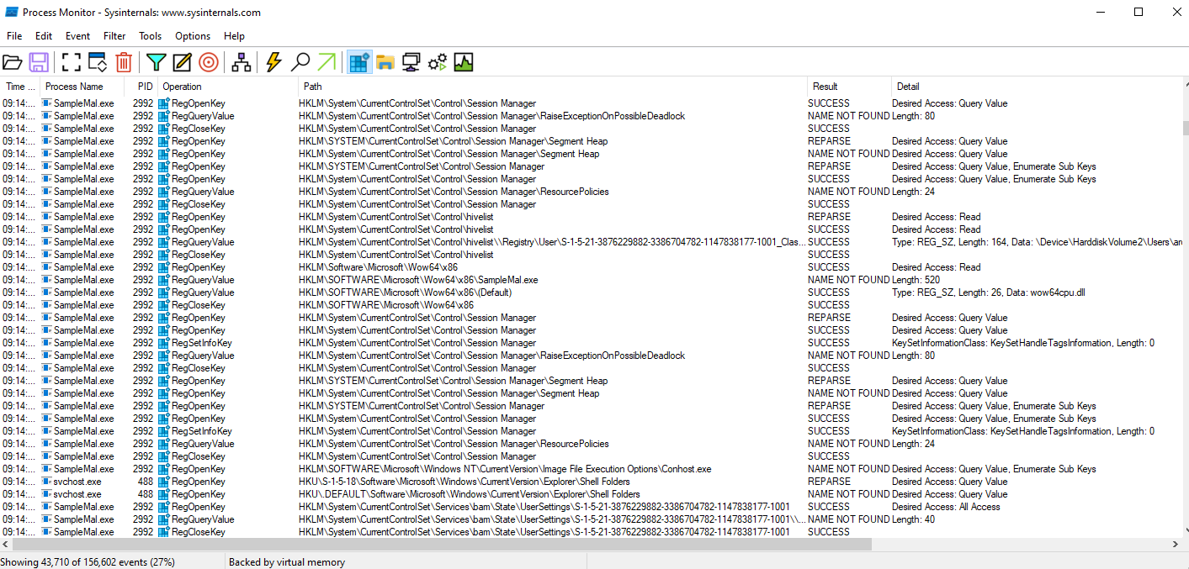
Then there is the conhost.exe which opens when the SampleMal.exe is ran, this screenshot shows that the console also edits the registry, but in both HKLM and HKCU paths.
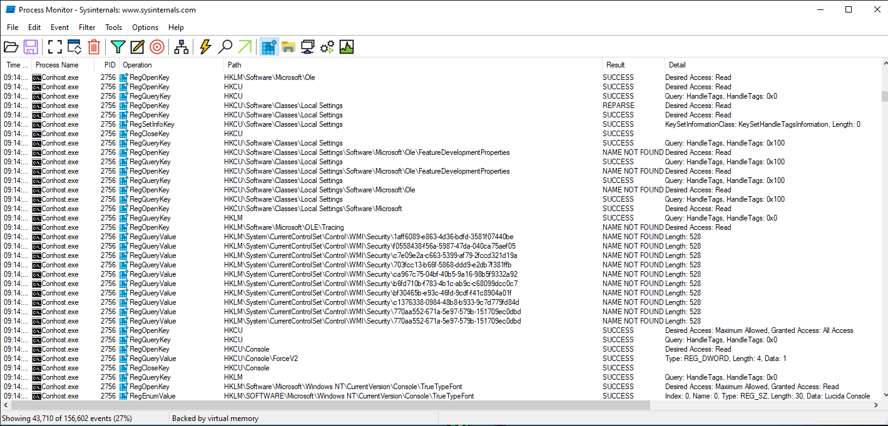
Further down looking at the same conhost.exe it shows the RegQueryValue operation for HKCU\Console path, and gets the value for stuff like InsertMode, FontFamily, WindowPosition etc.
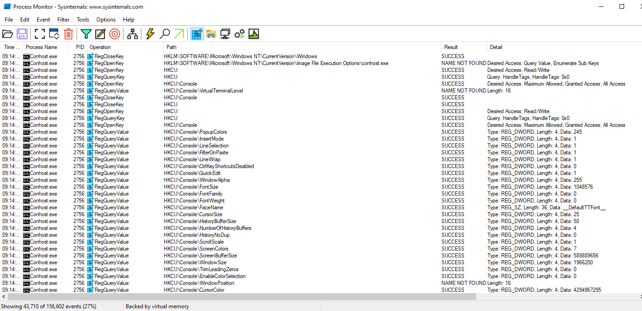

Using OllyDbg to run the malware and find out the execution flow and behaviour of the malware, this screenshot shows that it opens up a blank console and interacts with the Kernal32 API aswell as WININET API using functions like WININET.InternetOpenW, WININET.InternetConnectW, WININET.FtpGetFile, WININET.InternetCloseHandle.
A combination of these operations, therefore, suggests that the malware is set up such that it communicates to a remote server, most likely to download more payloads as well as receive commands from a central point. This is common behaviour among many types of malwares like botnets, ransomware and other malicious software because they need to communicate with a command and control server to function. (Grimmick, 2021)

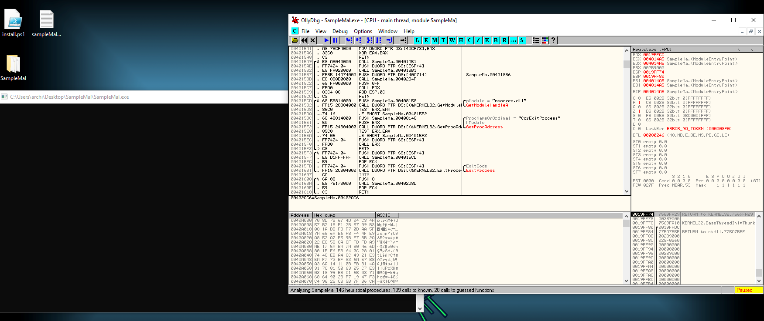
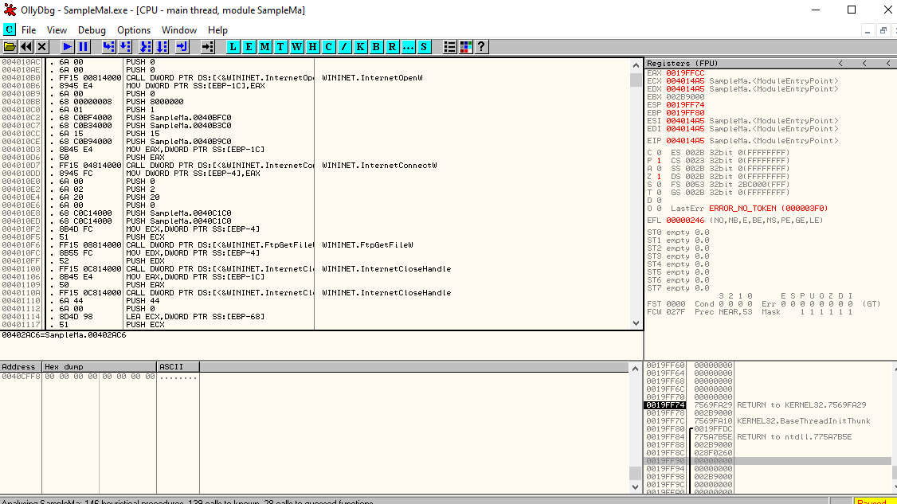

Structure of the main function:
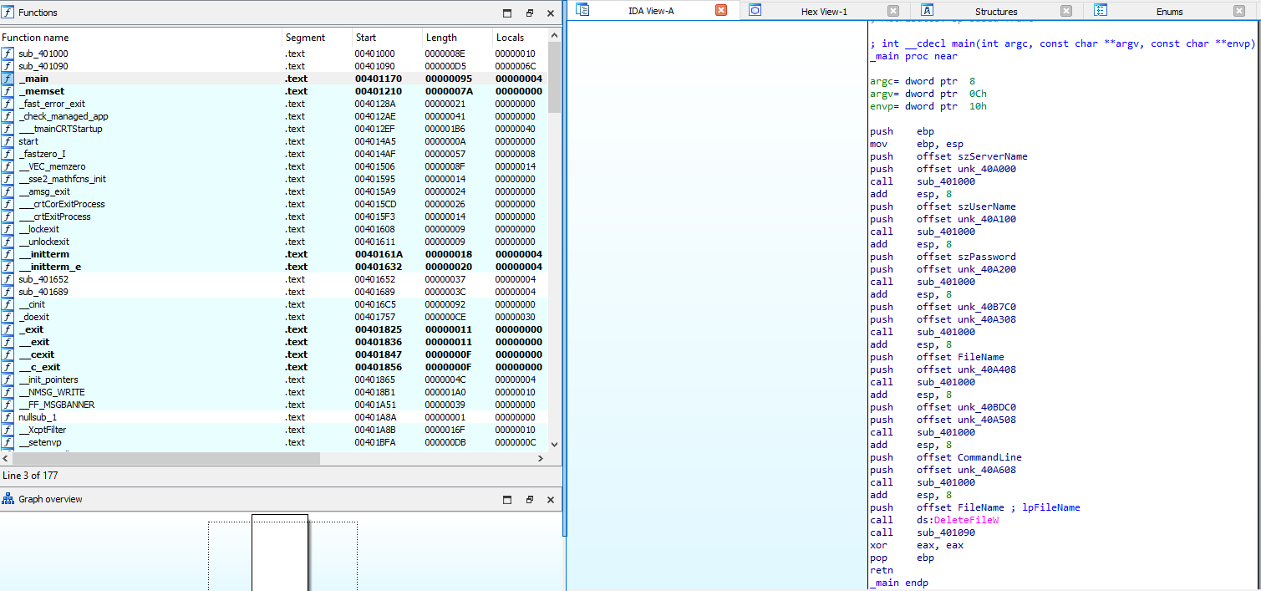
The parameters for this function include argc, argv, envp. Those are routine parameters for main function in C/C++ that stands for number of command line arguments, an array of argument strings and an array of environment strings respectively. (stackoverflow, 2011)
The structure of the main function starts with a standard prologue for a C function, which is used to save the base pointer (ebp) and sets up a new stack frame. This pattern is very common in C and C++ programs as it involves preparing storage space for local variables as well as preserving the previous stack frame. (Cortuk, 2024)
Then there are subroutine calls with different parameters for each call the main function calls on a subroutine (sub_401000). Each call pushes two parameters onto the stack before calling the subroutine. (Eastwood, 2022) These parameters consist of string offsets (szServerName, szUserName, szPassword, FileName, CommandLine) and other unknown values (unk_40A000, unk_40A100, unk_40A200, unk_40A308, unk_40A408, unk_40A508, unk_40A608, unk_40B7C0, unk_40BDC0). From these calls, it appears that the main function might be setting up or configuring something to do with network connections or file operations due to their context and what is inside the SampleMalStrings.txt findings.
Near the end of the main function after the subroutine calls there is a deletefileW; this Windows API call deletes a file. For DeleteFileW method called here takes one argument FileName which is a pushed string offset, this suggests the main function is meant to delete a specified file. (alvinashcraft, 2024)
The main function ends with a standard epilogue for a C function, where it tidies up the stack frame and reinstates the base pointer. It then goes back to the caller signalling completion with eax having a value of zero. Then uses pop ebp to restore the calling functions stack frame. (Stackoverflow, 2013)
To sum it up the primary function seems to be preparing or adjusting network connections or file tasks. Subsequently, it removes a file. Then, calls another subroutine (sub_401090) before finishing and returning. Further dynamic analysis will be required to find out how the Malware operates in real-time.
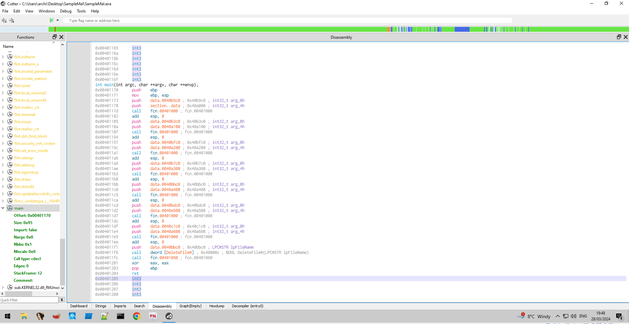
Using the Cutter reverse-engineering tool to show the assembly code for the malware which is a lot more in-depth than IDA free as it shows you a lot more raw data.
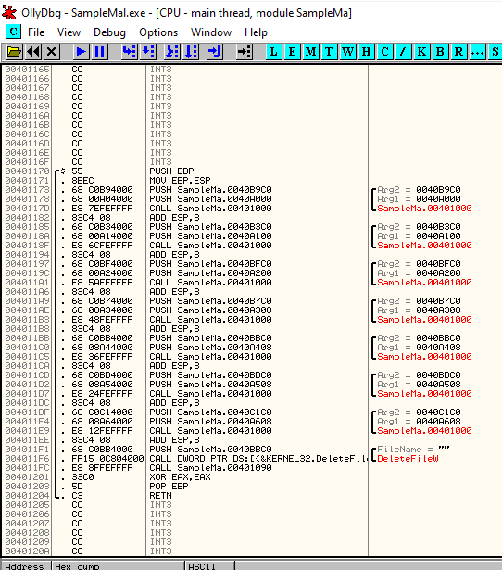
Using OllyDbg this bit of the SampleMal seems to Call two Arg values for each push and add to esp,8 and then calls a DeleteFileW in the Kernel32 and then calls the SampleMalware.
This means that the malware is putting some arguments into the stack before the call to DeleteFileW which then tells us that it is going to delete a file. This can be a part of its mechanism for self-destruction to escape detection or clear out after doing its thing. Furthermore, another call following SampleMal could re-execute the malware, changing its behaviour and packing additional payloads of malicious data.
Identification of de-obfuscation function:
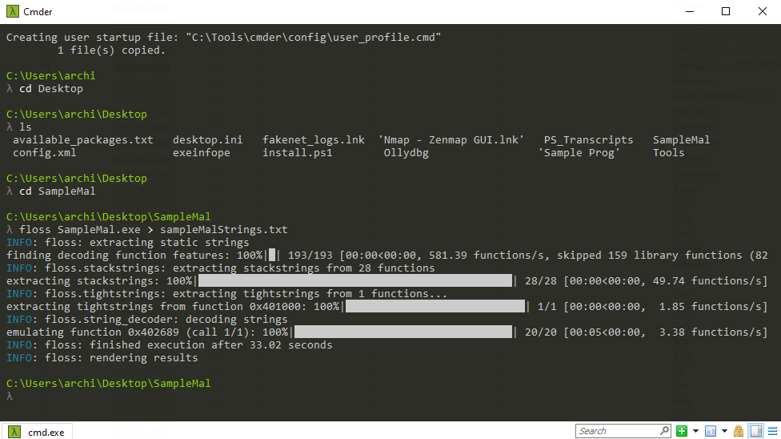
Using Cmder which is a portable console emulator, and I am going into the directory of the SampleMal file and using the FLOSS function which is “FLARE Obfuscated String Solver (FLOSS, formerly FireEye Labs Obfuscated String Solver) which uses advanced static analysis techniques to automatically extract and deobfuscate all strings from malware binaries”. (GitHub/Mandiant, 2024)
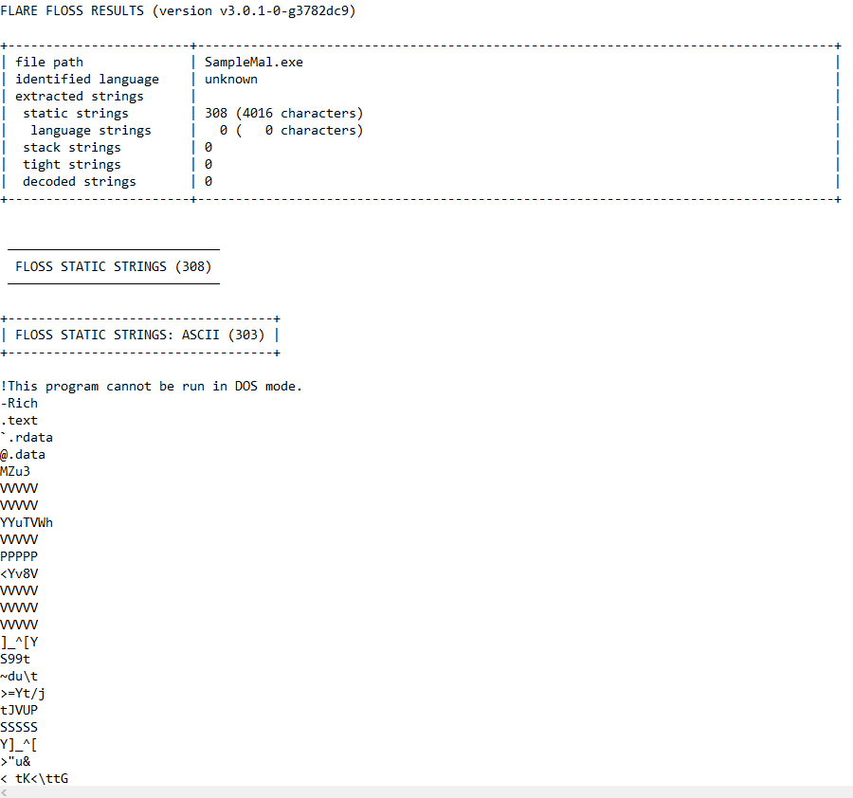
The fixed strings contain different kinds of ASCII characters including alphanumeric, punctuation marks and special symbols.
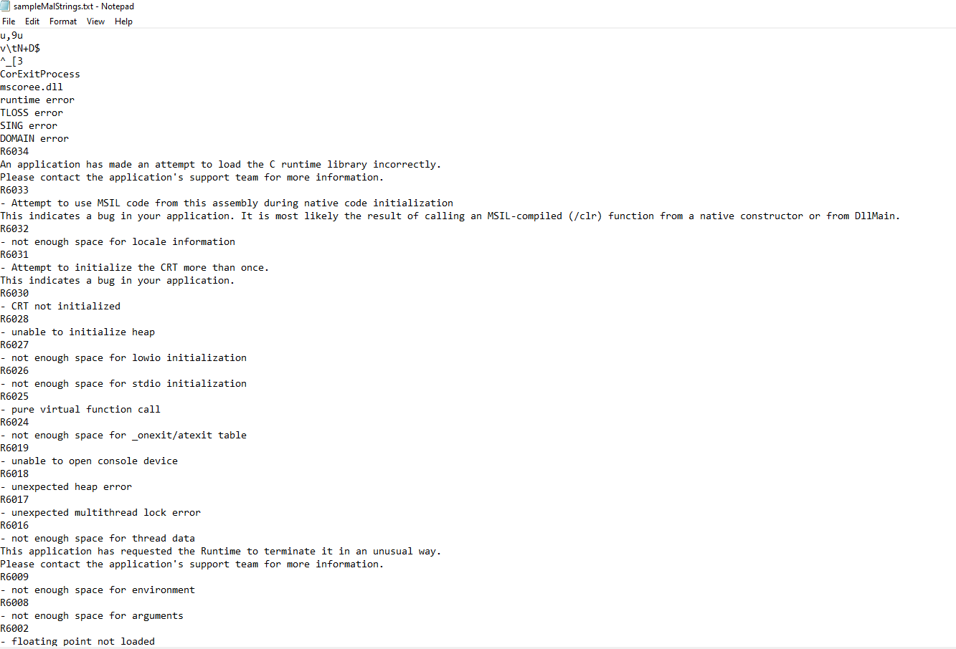
From the references to runtime error messages and those concerning Microsoft Visual C++ Runtime Library, it can be inferred that the malware may interact with various Windows operating system libraries or components.
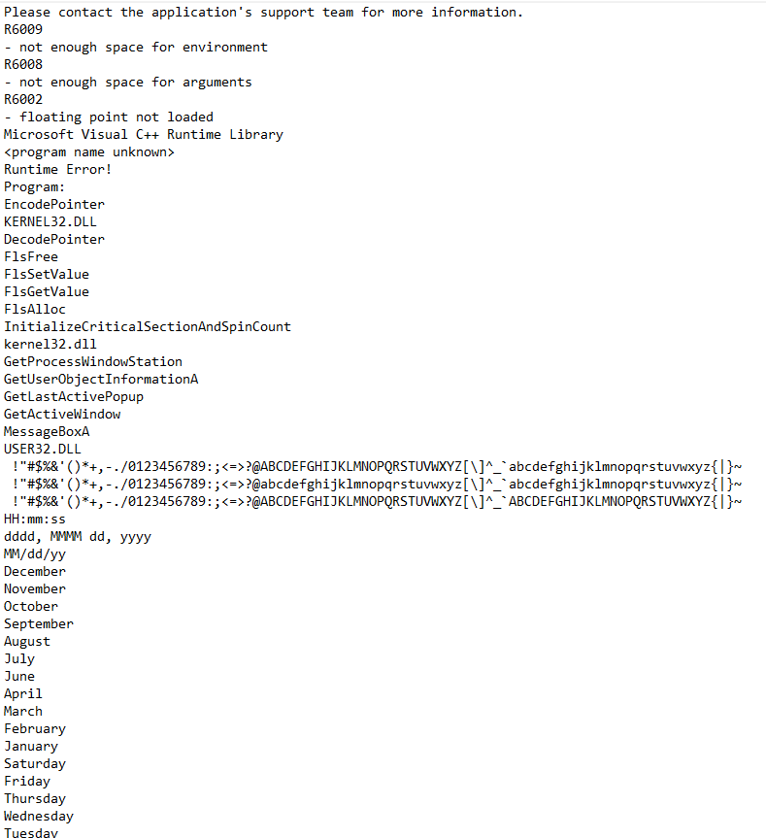
There are references of date and time formats so could suggest information gathering by the malware or operations based on time. Various cryptographic functions like EncodePointer and DecodePointer were used which indicated possible employment of encryption techniques or obfuscation methods. (Microsoft, 2018)
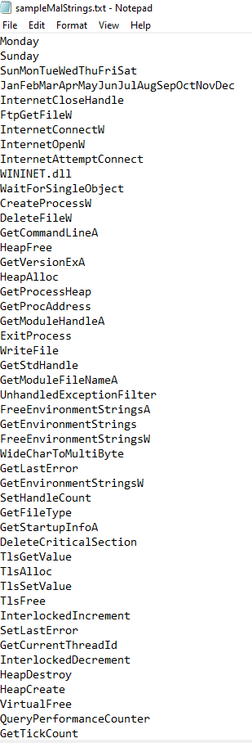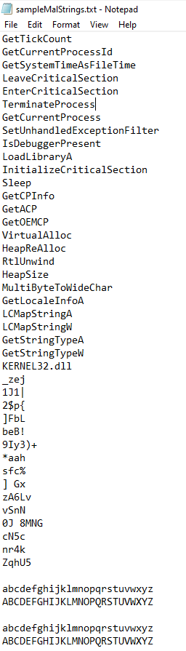
There are internet-related functions from WININET.dll which could mean that this potentially involves activities through network such as downloading files from FTP servers or HTTP connections made. (Pilici, 2023) Some WinAPI function names appear in which this suggests that the malware is using Windows API calls for diverse operations like process creation, file manipulation and network communication. (Patra, 2024)

Advice for preventing and minimizing attacks:
This advice is critical for preventing and minimizing malware attacks, necessitating the adoption of a comprehensive approach that includes regular system updates and patches, strong antivirus and firewall solutions, cyber security education focusing on best practices like not clicking on links or opening attachments from unknown sources and using network security. Educating users to recognize phishing attempts as well as the significance of secure networks and VPNs is significant. Preventing harmful activities is possible when malware has limited rights through denying user access and application permissions in line with least privilege principles. Employing anti-malware, firewalls in conjunction with threat intelligence feeds can improve detection capability for identifying malware C2 traffic. The last essentialities include ensuring that all software applications are updated, deploying endpoint visibility tools, verifying data backup and recovery mechanisms among others Network segmentation creates micro-perimeters against sensitive information assets hence preventing lateral movement within the network. Lastly, being up to date on the latest malware threats and security best practices will help maintain a proactive defence against cyber-attacks. (National Cyber Security Centre, 2020)

Conclusion:
My research reveals that SampleMal is quite a sophisticated piece of malware with capabilities that include process creation, file manipulation as well as network communication. It has encryption technologies whereby obfuscation techniques are employed to conceal itself while its network communication indicate direction from Command and Control (C2) servers. This study underscores the significance of a controlled virtualized environment for conducting malware analysis where malicious software can be safely studied without compromising the integrity on the host system. The discoveries assist in understanding behaviours exhibited by malwares thus providing valuable information for developing effective countermeasures against the highlighted exploits of the malware in this document.

References:
mdlee (2005). WININET.dll infected. [online] DELL Technologies. Available at: https://www.dell.com/community/en/conversations/virus-spyware/wininetdll-infected/647e5ef0f4ccf8a8de35c6c8 [Accessed 26 Mar. 2024].
alvinashcraft (2024). DeleteFileW function (fileapi.h) - Win32 apps. [online] learn.microsoft.com. Available at: https://learn.microsoft.com/en-us/windows/win32/api/fileapi/nf-fileapi-deletefilew [Accessed 27 Mar. 2024].
Collins, G. (2023a). Analyzing the Zeus Banking Trojan - Malware Analysis Project 101. [online] www.youtube.com. Available at: https://www.youtube.com/watch?v=USNOmFcebcU [Accessed 27 Mar. 2024].
Collins, G. (2023b). Build a Malware Analysis Lab (Self-Hosted & Cloud) - The Malware Analysis Project 101. [online] www.youtube.com. Available at: https://www.youtube.com/watch?v=rmSIm3BKu3Y&t=2270s [Accessed 26 Mar. 2024].
Cortuk, D. (2024). Function Prologue and Epilogue. [online] Medium. Available at: https://medium.com/@derya.cortuk/function-prologue-and-epilogue-b999f9637f77 [Accessed 27 Mar. 2024].
Eastwood, C. (2022). Lab 6 — C Code Constructs in Assembly. [online] Malware Analysis. Available at: https://medium.com/ce-malware-analysis/lab-6-c-code-constructs-in-assembly-e8f22078600c [Accessed 27 Mar. 2024].
F-Secure (2024). Kriz | F-Secure Labs. [online] www.f-secure.com. Available at: https://www.f-secure.com/v-descs/kriz.shtml#:~:text=Kriz%20is%20a%20memory%20resident [Accessed 26 Mar. 2024].
feroot (2023). What is a Command-and-Control (C2) Server? [online] Feroot. Available at: https://www.feroot.com/education-center/what-is-a-command-and-control-c2-server/#:~:text=A%20command%2Dand%2Dcontrol%20(C2)%20server%20is%20a [Accessed 28 Mar. 2024].
Fisher, T. (2021). What Is a DLL File and Why Are They Important? [online] Lifewire. Available at: https://www.lifewire.com/what-is-a-dll-file-2625852 [Accessed 27 Mar. 2024].
Fortuna, A. (2017). Malware persistence techniques. [online] Andrea Fortuna. Available at: https://andreafortuna.org/2017/07/06/malware-persistence-techniques/ [Accessed 29 Mar. 2024].
GitHub/Mandiant (2024). mandiant/flare-floss. [online] GitHub. Available at: https://github.com/mandiant/flare-floss [Accessed 27 Mar. 2024].
Grimmick, R. (2021). What is C2? Command and Control Infrastructure Explained. [online] www.varonis.com. Available at: https://www.varonis.com/blog/what-is-c2 [Accessed 29 Mar. 2024].
Kaspersky (2024). Indicator of Compromise (IoC). [online] encyclopedia.kaspersky.com. Available at: https://encyclopedia.kaspersky.com/glossary/indicator-of-compromise-ioc/ [Accessed 26 Mar. 2024].
Mandiant (2020). capa: Automatically Identify Malware Capabilities. [online] Mandiant. Available at: https://www.mandiant.com/resources/blog/capa-automatically-identify-malware-capabilities [Accessed 28 Mar. 2024].
Microsoft (2018). EncodePointer function (Windows). [online] learn.microsoft.com. Available at: https://learn.microsoft.com/en-us/previous-versions/bb432254(v=vs.85) [Accessed 27 Mar. 2024].
MITRE (2024). Shared Modules, Technique T1129 - Enterprise | MITRE ATT&CK®. [online] attack.mitre.org. Available at: https://attack.mitre.org/techniques/T1129/ [Accessed 28 Mar. 2024].
Mitre (2024a). Obfuscated Files or Information, Technique T1027 - Enterprise | MITRE ATT&CK®. [online] attack.mitre.org. Available at: https://attack.mitre.org/techniques/T1027/ [Accessed 28 Mar. 2024].
Mitre (2024b). System Network Configuration Discovery, Technique T1016 - Enterprise | MITRE ATT&CK®. [online] attack.mitre.org. Available at: https://attack.mitre.org/techniques/T1016/ [Accessed 28 Mar. 2024].
National Cyber Security Centre (2020). Mitigating malware and ransomware attacks. [online] www.ncsc.gov.uk. Available at: https://www.ncsc.gov.uk/guidance/mitigating-malware-and-ransomware-attacks [Accessed 29 Mar. 2024].
okta (2023). RC4 Encryption Algorithm Stream Ciphers Defined | Okta. [online] www.okta.com. Available at: https://www.okta.com/identity-101/rc4-stream-cipher/ [Accessed 28 Mar. 2024].
Patra, R. (2024). WinAPI and Registry Malware Analysis. [online] www.linkedin.com. Available at: https://www.linkedin.com/pulse/winapi-registry-malware-analysis-rakesh-patra-uybbc [Accessed 27 Mar. 2024].
Pilici, S. (2023). Kernel32.dll: What It Is & How To Fix Errors. [online] Malwaretips. Available at: https://malwaretips.com/blogs/kernel32-dll-what-it-is-how-to-fix-errors/#:~:text=The%20kernel%20is%20the%20core,interact%20with%20the%20operating%20system. [Accessed 26 Mar. 2024].
Stackoverflow (2013). Function Prologue and Epilogue in C. [online] Stack Overflow. Available at: https://stackoverflow.com/questions/14765406/function-prologue-and-epilogue-in-c#:~:text=The%20epilog%3A [Accessed 27 Mar. 2024].
stackoverflow (2011). c++ - What does int argc, char *argv[] mean? [online] Stack Overflow. Available at: https://stackoverflow.com/questions/3024197/what-does-int-argc-char-argv-mean [Accessed 27 Mar. 2024].

